Project Report Format

# INTRODUCTION

* 1. **Project Overview**

Social media platforms have become integral parts of our daily lives, serving as hubs for communication, entertainment, and information sharing. Analyzing social media data is essential for businesses, researchers, and individuals to understand trends, user behavior, and sentiment. This project aims to provide an overview of how to analyze social media data, including data collection, processing, and analysis.

The primary objective of this project is to demonstrate the process of collecting and analyzing social media data to derive valuable insights. This analysis can be used for a variety of purposes, such as market research, sentiment analysis, trend prediction, and brand monitoring.

The project for the analysis of social media seeks to delve deep into the dynamic world of online communication and engagement. With the ever-increasing importance of social media platforms in shaping public discourse, brand perception, and consumer behavior, the objectives are multi-faceted.

The project aims to provide a comprehensive understanding of user behavior, engagement metrics, and demographics on various social media platforms, considering the unique characteristics of each. Through natural language processing (NLP) techniques, the analysis will uncover sentiments, trends, and patterns in social media content, empowering stakeholders to adapt their strategies effectively.

Additionally, competitive analysis will reveal insights into the relative performance of different entities within the digital landscape. Ethical considerations and data privacy compliance will be paramount, ensuring the responsible handling of user data. By offering actionable recommendations and aligning the analysis with broader business goals, the project will contribute to informed decision-making processes.

Continuous social listening, crisis management plans, and cross-platform analysis will further enhance the project's relevance and practicality in the ever-evolving social media ecosystem. Lastly, a robust reporting structure and post-project evaluation will assess the impact of recommendations, providing a feedback loop for future improvements in social media strategies and engagement.

* 1. **Purpose**

**Market Research:** Understanding consumer sentiment, trends, and preferences by analyzing what people are saying on social media. This can help businesses make informed decisions about their products or services.

**Brand Monitoring:** Tracking mentions and conversations about a specific brand to gauge brand perception, monitor for crises, and manage reputation.

**Competitor Analysis:** Studying the social media presence and activities of competitors to identify opportunities, weaknesses, and threats.

**Audience Insights:** Gaining a better understanding of the demographics, interests, and behaviors of an audience to create more targeted and effective marketing campaigns.

**Content Strategy:** Analyzing the performance of different types of content (e.g., videos, articles, infographics) to refine a content strategy.

**Customer Feedback:** Collecting and analyzing feedback from customers and clients on social media to improve products or services.

**Public Opinion Research:** Gathering data for political, social, or academic research to understand public sentiment on various topics.

**Event Monitoring:** Keeping track of social media conversations related to a specific event, conference, or campaign.

**Product Development:** Using social media insights to inform the development of new products or features that align with customer needs and desires.

**Social Listening:** Keeping an ear on social media discussions to stay attuned to industry trends, news, and emerging issues.

**Community Building:** Creating and nurturing a social media community around a brand, cause, or topic.

**Risk Assessment:** Identifying potential risks and opportunities for a business by analyzing social media conversations and industry trends.

# LITERATURE SURVEY

* 1. **Existing problem**

A literature survey for an analysis of social media project should start by reviewing relevant academic research and publications that provide insights into existing problems and challenges in this field. Here are some key areas and common problems to consider when conducting a literature survey for a social media analysis project:

**Data Collection and Analysis:**

**Data Volume and Variety:** Social media platforms generate massive amounts of data, making it challenging to collect and process efficiently.

**Data Privacy and Ethics:** Maintaining user privacy and ensuring ethical data collection is a critical concern.

**Data Quality:** Social media data often contains noise, fake accounts, and irrelevant information, which can affect the accuracy of analyses.

**Sentiment Analysis:**

**Detecting Sarcasm and Irony:** Understanding nuanced expressions in social media posts, such as sarcasm and irony, can be challenging for sentiment analysis algorithms.

**Contextual Understanding:** Analyzing the sentiment of a post in its proper context can be difficult, as social media posts are often short and lack context.

**User Behavior Analysis:**

**Identifying Bots and Fake Accounts:** Social media platforms are plagued by automated bots and fake accounts, making it essential to detect and mitigate their impact on user behavior analysis.

**Predictive Modeling:** Predicting user behavior, such as trending topics, viral content, and engagement patterns, can be challenging due to the dynamic nature of social media.

**Social Network Analysis:**

**Influence and Spread Analysis:** Understanding how information and trends propagate through social networks and identifying influential users is a complex task.

**Community Detection:** Identifying and characterizing communities within social networks and understanding their dynamics can be challenging.

**Hate Speech and Toxicity Detection:**

**Ambiguity and Context:** Detecting hate speech and toxic content often requires understanding the context and intent behind user posts, which can be challenging for automated algorithms.

**Multilingual Challenges:** Social media is a global platform, and hate speech detection may need to address multiple languages and cultures.

**Fake News and Misinformation:**

**Content Verification:** Assessing the credibility and authenticity of social media content, particularly during breaking news events, is a significant challenge.

**Information Cascades:** Studying how false information spreads and correcting it can be complex.

**User Privacy and Data Security:**

**Protecting User Data:** Ensuring the privacy and security of user data in social media analysis is an ethical and technical concern.

**Compliance with Regulations:** Social media data analysis projects must adhere to data protection laws and regulations.

**Machine Learning and AI Algorithms:**

**Algorithm Bias:** Machine learning algorithms used in social media analysis can exhibit biases that impact the fairness and accuracy of results.

**Scalability:** Ensuring that algorithms can handle the vast amount of social media data efficiently is a practical challenge.

**Emerging Platforms and Trends:**

Studying the impact of emerging social media platforms and trends on user behavior and communication is a constantly evolving area of study.

* 1. **References**

A literature survey or review is an important component of any research project, including an analysis of social media. It helps you understand the existing research and identify gaps in the field. Below, I'll provide a list of references and key areas to consider when conducting a literature survey for a social media analysis project.

**Social Media Analysis Methods:**

**Boyd, D., & Crawford, K. (2012).** Critical questions for big data: Provocations for a cultural, technological, and scholarly phenomenon. Information, Communication & Society, 15(5), 662-679.

**Ritter, A., et al. (2012).** Open domain event extraction from twitter. In Proceedings of the 18th ACM SIGKDD international conference on Knowledge discovery and data mining (KDD), 1104-1112.

**Sentiment Analysis:**

**Pang, B., & Lee, L. (2008).** Opinion mining and sentiment analysis. Foundations and Trends® in Information Retrieval, 2(1-2), 1-135.

**Liu, B. (2012).** Sentiment analysis and opinion mining. Synthesis Lectures on Human Language Technologies, 5(1), 1-167.

**User Behavior and Engagement:**

**Shao, C., Ciampaglia, G. L., & Flammini, A. (2017).** Hoaxy: A platform for tracking online misinformation. Proceedings of the 26th International Conference on World Wide Web, 1033-1036.

**Hutto, C. J., & Gilbert, E. (2014).** VADER: A parsimonious rule-based model for sentiment analysis of social media text. Eighth International Conference on Weblogs and Social Media (ICWSM-14).

**Fake News and Misinformation:**

**Vosoughi, S., Roy, D., & Aral, S. (2018).** The spread of true and false news online. Science, 359(6380), 1146-1151.

**Friggeri, A., Adamic, L. A., & Eckles, D. (2014).** Rumor Cascades. Proceedings of the Eighth International Conference on Weblogs and Social Media (ICWSM-14).

**Social Network Analysis:**

**Wasserman, S., & Faust, K. (1994).** Social Network Analysis: Methods and Applications. Cambridge University Press.

**Newman, M. E. (2003).** The structure and function of complex networks. SIAM review, 45(2), 167-256.

**Ethical and Privacy Concerns:**

**boyd, d., & Crawford, K. (2012).** Critical questions for big data: Provocations for a cultural, technological, and scholarly phenomenon. Information, Communication & Society, 15(5), 662-679.

**Tufekci, Z. (2014).** Big questions for social media big data: Representativeness, validity and other methodological pitfalls. ICWSM, 505-514.

**Impact on Society:**

**Coviello, L., et al. (2014).** Detecting emotional contagion in massive social networks. PLOS ONE, 9(3), e90315.

**Pariser, E. (2011).** The Filter Bubble: What the Internet is Hiding from You. Penguin UK.

* 1. **Problem Statement Definition**

In the era of digital communication and online interaction, social media platforms have become integral to the lives of individuals and the operations of businesses and organizations. However, there exists a critical need to understand and analyze the impact, trends, and dynamics of social media in various domains. The problem statement for our "Analysis of Social Media" project is as follows:

**Problem Description:**

The rapid growth and evolution of social media platforms have generated vast amounts of data, including text, images, videos, and user interactions. This data presents a valuable opportunity for insights and decision-making, but it also poses challenges in terms of volume, variety, and velocity.

**Lack of Comprehensive Understanding:**

There is a lack of comprehensive understanding regarding the role of social media in shaping public opinion, influencing consumer behavior, and affecting political and social discourse. Stakeholders, including businesses, governments, and researchers, require actionable insights to adapt to this dynamic landscape.

**Information Overload:**

The sheer volume of social media content makes it difficult to discern meaningful patterns, sentiments, and emerging trends. Traditional methods of analysis are often insufficient to extract valuable information from this massive and continuously generated dataset.

**Ethical and Privacy Concerns:**

The ethical use of social media data, as well as the protection of user privacy, are increasingly important concerns. It is essential to address these ethical considerations while conducting analysis.

**Project Objective:**

Our project aims to address these challenges by conducting a comprehensive analysis of social media data to extract actionable insights. We will explore topics such as sentiment analysis, trend detection, and user behavior modeling. Additionally, we will take into account ethical and privacy considerations in our analysis.

# IDEATION & PROPOSED SOLUTION

* 1. **Empathy Map Canvas**

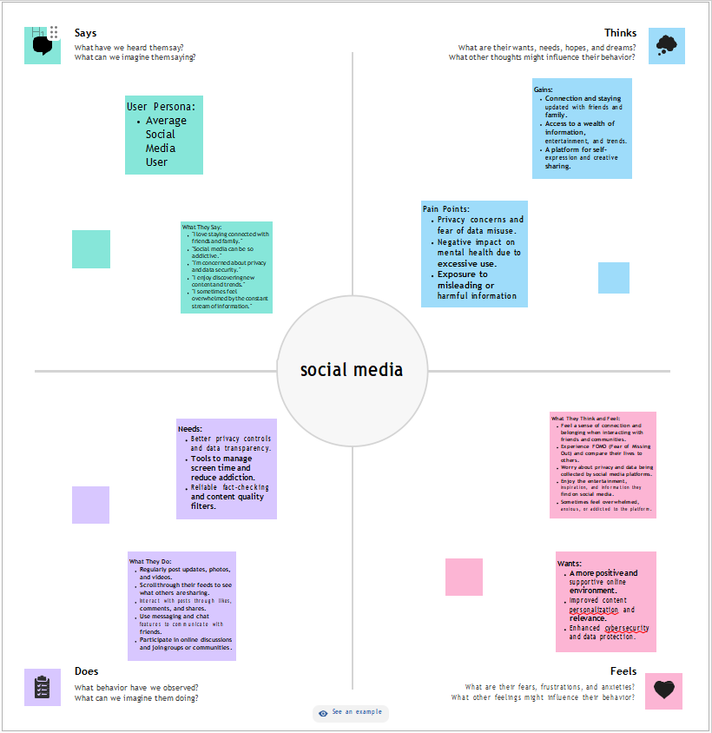

* 1. **Ideation & Brainstorming**

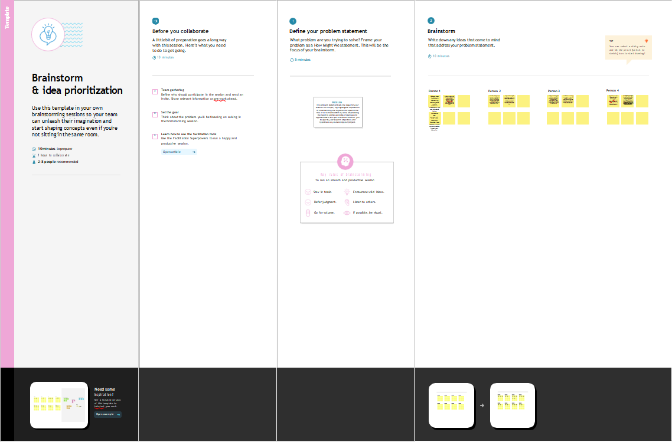

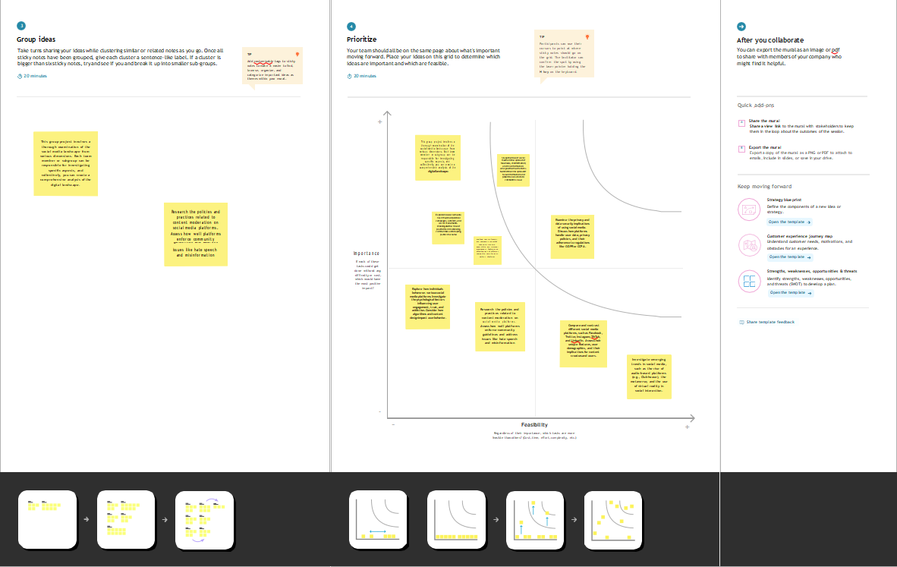

# REQUIREMENT ANALYSIS

* 1. **Functional requirement**

# Analyzing a social media project involves understanding its functional requirements, which are the specific features and capabilities the project needs to achieve its goals. Below are some key functional requirements for analyzing a social media project:

# Data Collection:

# Data sources: Specify the social media platforms from which data will be collected (e.g., Facebook, Twitter, Instagram).

# Data types: Define the types of data to collect, such as text, images, videos, user profiles, and metadata.

# Data volume: Determine the scale of data to be collected, including frequency and historical data.

# Data Retrieval and Storage:

# 

# API integration: Describe how the project will interact with social media platform APIs to retrieve data.

# Data storage: Specify where and how the collected data will be stored, such as databases, cloud storage, or data lakes.

# Data security: Ensure data privacy and compliance with relevant regulations, like GDPR.

# 

# Data Preprocessing:

# 

# Data cleaning: Detail the process of removing noise, duplicates, and irrelevant data.

# Data normalization: Standardize data formats and structures for analysis.

# Sentiment analysis: Include sentiment analysis tools to assess the emotional tone of content.

# User Profiling:

# User identification: Develop methods for identifying and categorizing users, including influencers, brands, and regular users.

# Demographics: Extract and analyze user demographics (e.g., age, gender, location).

# Behavior analysis: Analyze user behavior, such as posting frequency, engagement, and content preferences.

# Content Analysis:

# Text analysis: Implement natural language processing (NLP) to analyze text content for keywords, themes, and sentiment.

# Image and video analysis: Use image recognition and video processing techniques to analyze visual content.

# Trend analysis: Identify and track popular topics, hashtags, and trends within the social media data.

# Engagement Metrics:

# Likes, comments, shares: Measure user engagement with posts and content.

# Follower growth: Track user and brand follower/fan growth over time.

# Influencer performance: Evaluate the effectiveness of influencer marketing campaigns.

# Network Analysis:

# Social network graph: Build and analyze social networks to understand connections between users and brands.

# Community detection: Identify user communities and their interactions.

# Influence analysis: Determine influential users and their impact on the network.

# Reporting and Visualization:

# Dashboard: Create a user-friendly interface to visualize key metrics and insights.

# Reports: Generate automated reports with charts, graphs, and summaries for stakeholders.

# Alerting and Monitoring:

# Real-time monitoring: Set up alerts for critical events or sudden shifts in data.

# Anomaly detection: Implement algorithms to identify unusual patterns in social media activity.

# Scalability:

# Ensure the system can handle increasing data volumes and user activity.

# Plan for future growth and accommodate new social media platforms.

# User Access and Permissions:

# Role-based access control: Define who can access and manipulate the data and the system's features.

# Data privacy: Comply with data privacy laws and regulations, and protect sensitive information.

# Data Export and Integration:

# Provide options to export data for further analysis and reporting.

# Integrate with external tools and platforms, such as CRM systems or marketing automation software.

* 1. **Non-Functional requirements**

**Performance:**

**Response Time:** Define the maximum acceptable response time for processing and presenting social media data and insights.

**Scalability:** The system should be able to handle an increasing volume of social media data without a significant degradation in performance.

**Throughput:** Specify the number of social media posts or users the system should be able to process within a given time frame.

**Reliability:**

**Availability:** Determine the required uptime and availability percentage for the analysis system.

**Fault Tolerance:** Specify how the system should handle errors, recover from failures, and ensure continuous operation.

**Data Integrity:** Ensure the accuracy and integrity of social media data and insights.

**Security:**

**Data Privacy:** Address user data privacy and compliance with data protection regulations.

**Authentication and Authorization:** Specify how users and administrators will access and manage the system and data securely.

**Data Encryption:** Ensure that data in transit and at rest are encrypted to prevent unauthorized access.

**Scalability:**

**Elasticity:** Define how the system should scale resources up or down based on varying workloads.

**Load Balancing:** Implement load balancing to distribute the processing load evenly across servers or resources.

**Usability:**

**User Interface (UI):** Ensure that the user interface is intuitive, user-friendly, and accessible.

**Accessibility:** Make sure the system is accessible to users with disabilities and complies with accessibility standards.

**Compatibility:**

**Browser and Device Compatibility:** Specify the supported web browsers and devices for the user interface.

**API Compatibility:** Ensure that the system can work with various social media platforms' APIs and data formats.

**Data Management:**

**Data Retention:** Define data retention policies, especially for social media posts and user data.

**Backup and Recovery:** Plan for regular data backups and define a recovery strategy.

**Compliance:**

**Regulatory Compliance:** Ensure that the system complies with relevant regulations and industry standards, such as GDPR or HIPAA.

**Monitoring and Reporting:**

**Logging and Auditing:** Implement comprehensive logging and auditing mechanisms to track system activities.

**Performance Monitoring:** Set up tools for real-time monitoring of system performance and usage.

**Integration:**

**Third-Party Integration:** Define how the system will integrate with third-party tools, such as analytics or CRM systems.

**API Documentation:** Provide clear and comprehensive documentation for any APIs the system exposes.

**Localization and Internationalization:**

**Multilingual Support:** Specify the languages the system should support and the ability to analyze and present data in multiple languages.

**Operational Requirements:**

**Maintenance and Support:** Define the level of maintenance and support required to keep the system operational and up-to-date.

# PROJECT DESIGN

* 1. **Data Flow Diagrams & User Stories**

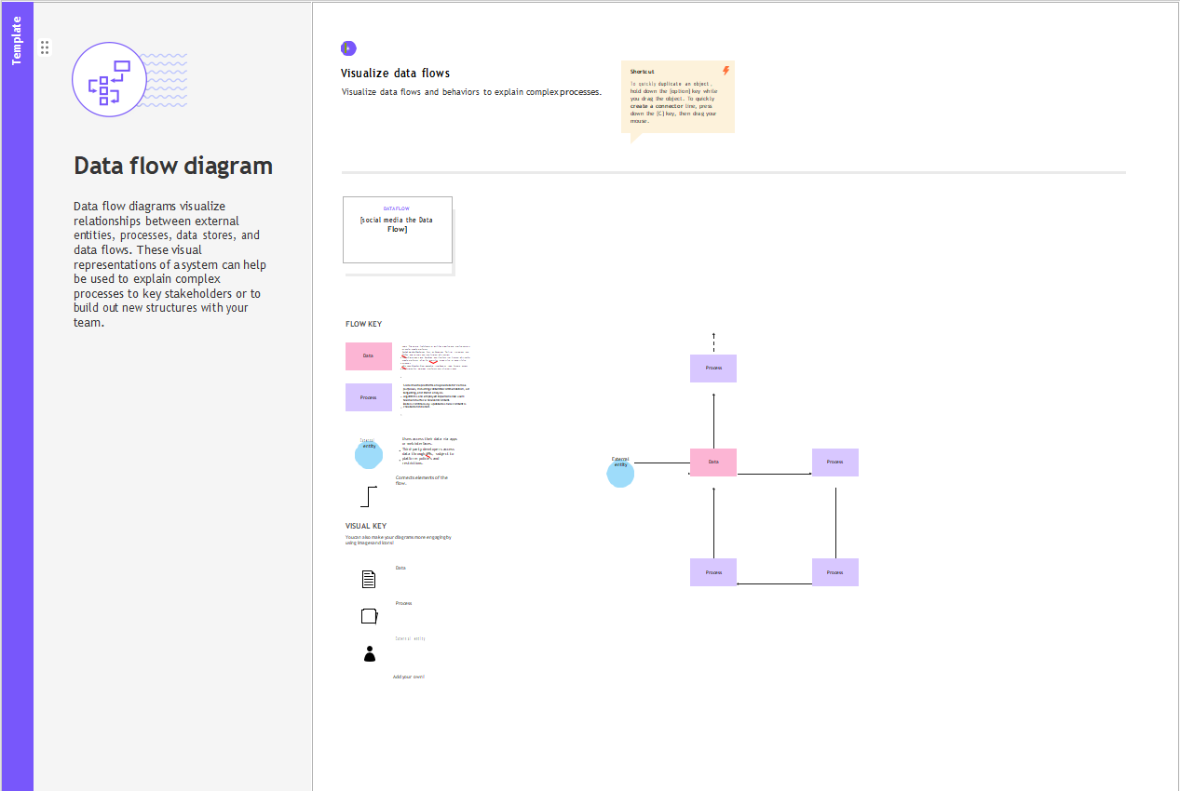

* 1. **Solution Architecture**

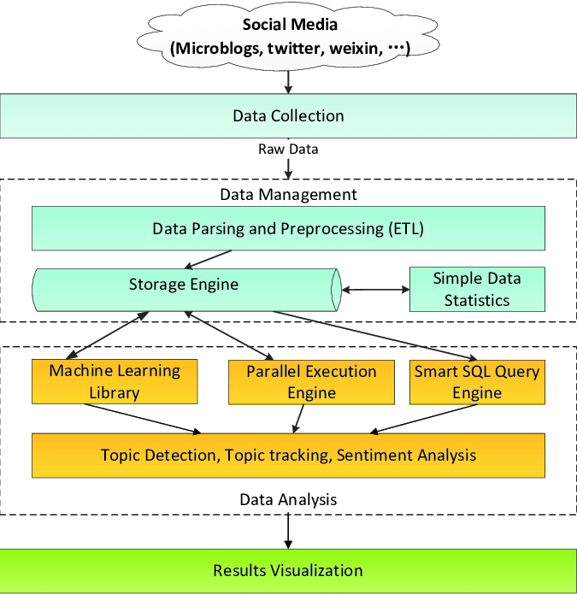

# PROJECT PLANNING & SCHEDULING

* 1. **Technical Architecture**

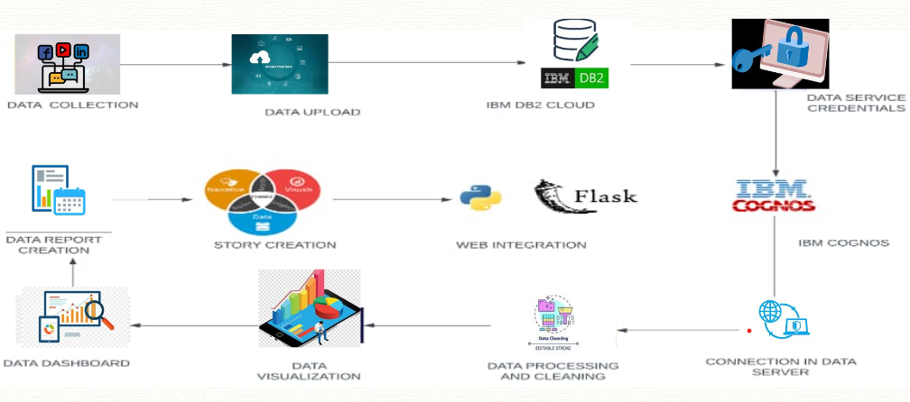

* 1. **Sprint Planning & Estimation**

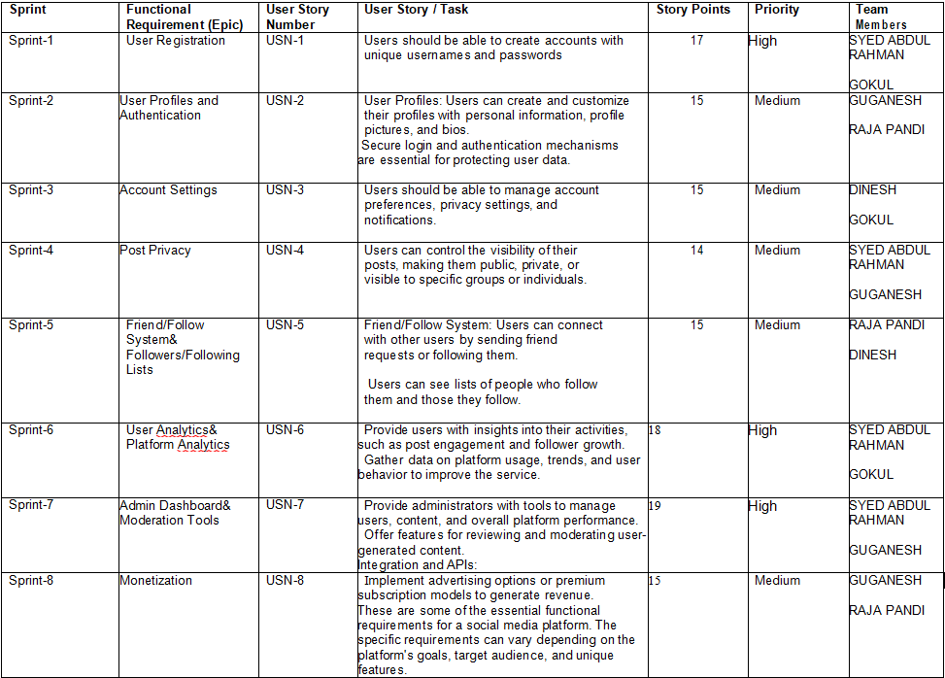

* 1. **Sprint Delivery Schedule**

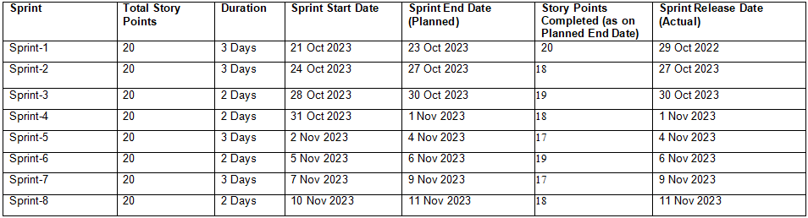

# CODING & SOLUTIONING (Explain the features added in the project along with code)

* 1. **Feature 1**

**Objectives and Goals:** Begin by identifying the project's overarching objectives and specific goals. What do you aim to achieve through your social media efforts?

**Key Performance Indicators (KPIs):** Define the KPIs that will help measure the success of your project. These could include metrics like engagement rate, follower growth, click-through rate (CTR), conversion rate, and more.

**Audience Analysis:** Understand your target audience, including demographics, interests, and behaviors. This will help tailor your content and engagement strategies.

**Content Strategy:** Assess the types of content you are producing and how they align with your objectives. Are you using text, images, videos, infographics, or a mix of formats?

**Content Calendar:** Review your posting schedule and the frequency of your content updates. Consistency is crucial in social media.

**Competitor Analysis:** Analyze what your competitors are doing on social media. What strategies are they using, and how do your efforts compare?

**Engagement Metrics:** Measure likes, shares, comments, and other forms of interaction to gauge how well your content resonates with your audience.

**Influencer Engagement:** If applicable, analyze the effectiveness of influencer partnerships in reaching your goals.

**Hashtag and Keyword Analysis:** Monitor the use of relevant hashtags and keywords in your posts and within your industry to improve discoverability.

**Community Management:** Assess how well you are responding to comments, questions, and concerns from your audience. Prompt and helpful responses can boost engagement and loyalty.

**Platform-Specific Metrics:** Different social media platforms have distinct features and metrics. For example, on Instagram, you may focus on metrics like reach and impressions, while on Twitter, you might prioritize retweets and mentions.

**Conversion Tracking:** If your goal is to drive specific actions (e.g., website visits, sign-ups, purchases), use tracking tools to measure conversions from social media.

**A/B Testing:** Conduct A/B tests on ad campaigns, landing pages, or content to determine what resonates best with your audience.

* 1. **Feature 2**

**Sentiment Analysis:** Use sentiment analysis tools to gauge how your audience feels about your brand or products based on comments and feedback.

**Data Visualization:** Create visual reports and dashboards to make data more digestible and actionable.

**Trend Analysis:** Stay updated on industry trends and incorporate relevant ones into your content strategy.

**Ad Performance:** If you run paid social media advertising, evaluate the performance of your ad campaigns, including click-through rates, ad relevance scores, and return on ad spend (ROAS).

**Compliance and Privacy:** Ensure your project complies with relevant data privacy regulations, such as GDPR or CCPA, and review your privacy policies.

**User Feedback and Surveys:** Collect feedback from your audience through surveys, polls, and direct messages to understand their preferences and concerns.

**Budget and Resource Allocation:** Analyze your project's budget and the allocation of resources to different social media channels and campaigns.

**Competitive Benchmarking:** Compare your social media project's performance to industry benchmarks and best practices.

**Emergency Response Plan:** Have a plan in place for handling social media crises, such as negative PR or social media backlash.

**Data Security:** Ensure that the data collected and stored through social media is secure and in compliance with data protection regulations.

**Accessibility:** Ensure that your social media content is accessible to all users, including those with disabilities.

**Sustainability:** Consider the environmental impact of your social media project and implement eco-friendly practices when possible.

* 1. **Database Schema (if Applicable)**

**User Profile Table:**

UserID (Primary Key)

Username

Name

Email

Location

Joining Date

**Social Media Platform Table:**

PlatformID (Primary Key)

PlatformName

PlatformURL

**Post Table:**

PostID (Primary Key)

UserID (Foreign Key to User Profile)

PlatformID (Foreign Key to Social Media Platform)

Content

PostDate

Likes

Shares

Comments

**Hashtag Table:**

HashtagID (Primary Key)

HashtagText

**PostHashtag Table (Many-to-Many Relationship):**

PostID (Foreign Key to Post)

HashtagID (Foreign Key to Hashtag)

**UserFollows Table (Many-to-Many Relationship):**

FollowerUserID (Foreign Key to User Profile)

FollowingUserID (Foreign Key to User Profile)

**UserLikesPost Table (Many-to-Many Relationship):**

UserID (Foreign Key to User Profile)

PostID (Foreign Key to Post)

**UserCommentsOnPost Table:**

CommentID (Primary Key)

UserID (Foreign Key to User Profile)

PostID (Foreign Key to Post)

CommentText

CommentDate

**SentimentAnalysis Table:**

AnalysisID (Primary Key)

PostID (Foreign Key to Post)

SentimentScore

SentimentLabel (e.g., Positive, Neutral, Negative)

**LocationData Table:**

LocationID (Primary Key)

LocationName

Latitude

Longitude

**UserLocation Table:**

UserID (Foreign Key to User Profile)

LocationID (Foreign Key to LocationData)

# PERFORMANCE TESTING

* 1. **Performance Metrics**

**Engagement Rate:** This measures the level of interaction your content receives, including likes, comments, shares, and clicks. It's often expressed as a percentage of your total followers or reach.

**Follower Growth:** Track the growth of your social media audience over time. This metric can help you gauge the effectiveness of your content and outreach efforts.

**Reach and Impressions:** Reach refers to the number of unique users who have seen your content, while impressions represent the total number of times your content has been displayed. These metrics indicate your content's exposure.

**Click-Through Rate (CTR):** CTR measures the percentage of users who clicked on a link or call-to-action in your social media posts. It's essential for tracking the effectiveness of driving traffic to your website or landing pages.

**Conversion Rate:** Calculate the percentage of users who completed a desired action (e.g., made a purchase, signed up for a newsletter) after interacting with your social media content.

**Bounce Rate:** If you're driving traffic to a website, track the percentage of visitors who leave the site after viewing only one page. A high bounce rate may indicate a mismatch between your content and landing page.

**ROI (Return on Investment):** Analyze the financial impact of your social media efforts by comparing the revenue generated with the cost of running campaigns and maintaining a social media presence.

**Customer Lifetime Value (CLV):** Determine the long-term value of a customer acquired through social media, considering their spending habits over time.

**Share of Voice:** Measure your brand's presence compared to competitors in your industry on social media. This metric helps assess your brand's visibility in the market.

**Social Media Traffic Sources:** Identify which social media platforms are driving the most traffic to your website or other conversion points.

**Social Media Ad Performance:** Evaluate the performance of paid social media advertising campaigns, including metrics like click-through rate, ad relevance score, and return on ad spend (ROAS).

**Content Performance:** Assess which types of content (e.g., videos, images, articles) perform best in terms of engagement and conversions.

**Customer Feedback and Sentiment:** Analyze comments, reviews, and direct messages to gauge the sentiment and feedback from your audience. This helps in understanding customer satisfaction and concerns.

**Response Time:** Measure how quickly your team responds to user inquiries or comments. A prompt response can positively impact your brand's reputation.

**Hashtag Performance:** Evaluate the effectiveness of branded and industry-specific hashtags in reaching a wider audience.

**Social Media Shareability:** Track how often your content is shared by your audience, as shares can significantly expand your reach.

**Customer Churn Rate:** Monitor the rate at which followers or subscribers unfollow or unsubscribe from your social media accounts. High churn may signal issues with your content or strategy.

**Audience Demographics:** Understand the demographics of your social media audience, including age, gender, location, and interests. This information helps refine your targeting and content strategies.

**Content Posting Frequency:** Analyze the optimal posting frequency for your audience to maintain engagement without overwhelming them.

**Social Media Influencer Metrics:** If you collaborate with influencers, assess their impact on your brand's reach and engagement.

**Data Privacy and Security Compliance:** Ensure that your project adheres to data privacy regulations and has proper security measures in place.

# RESULTS

* 1. **Output Screenshots**

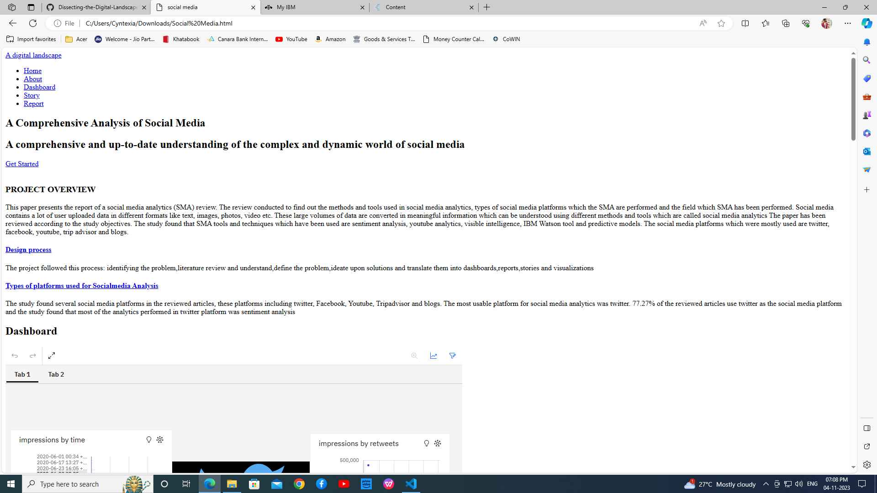

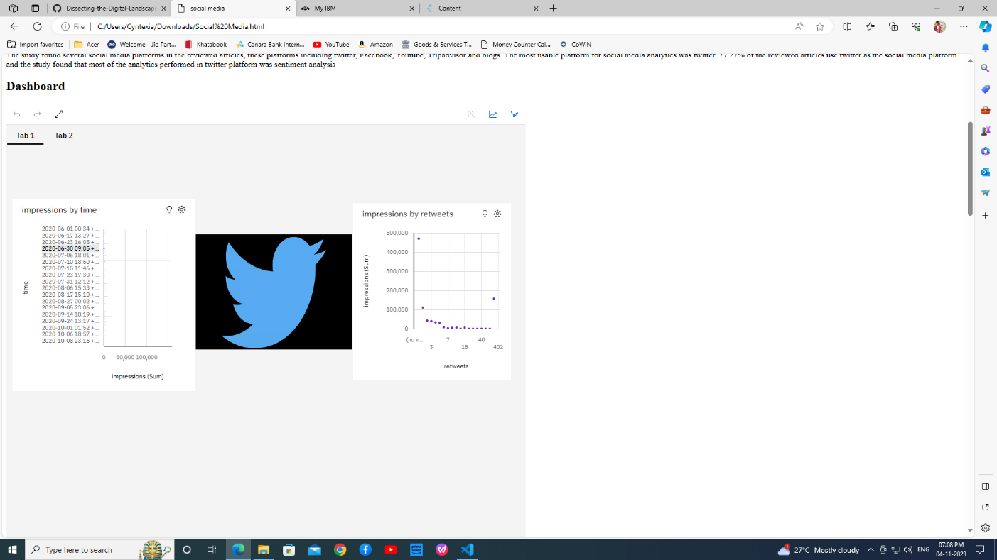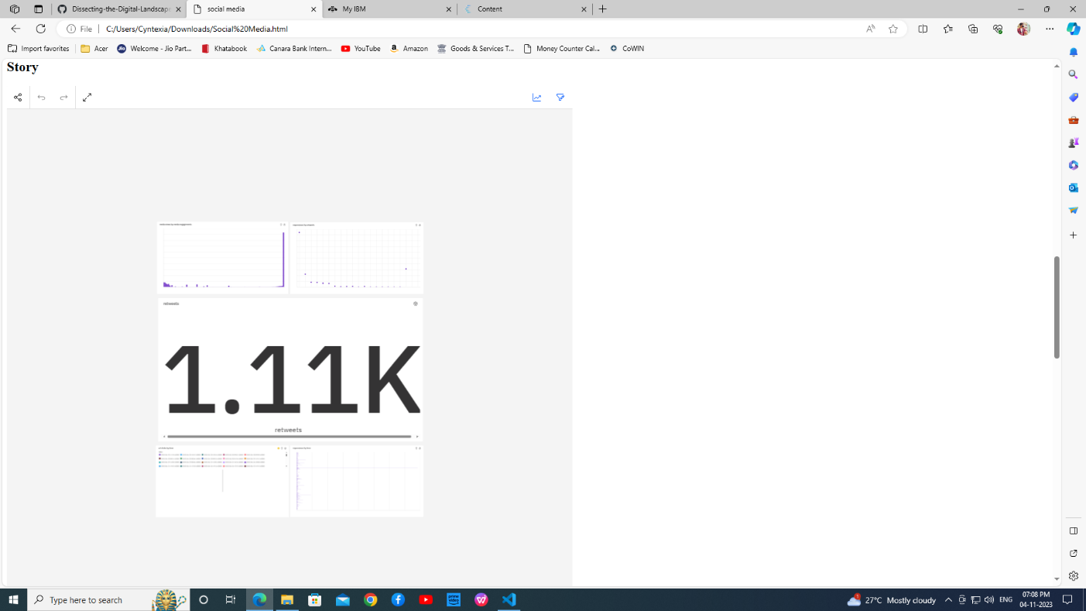

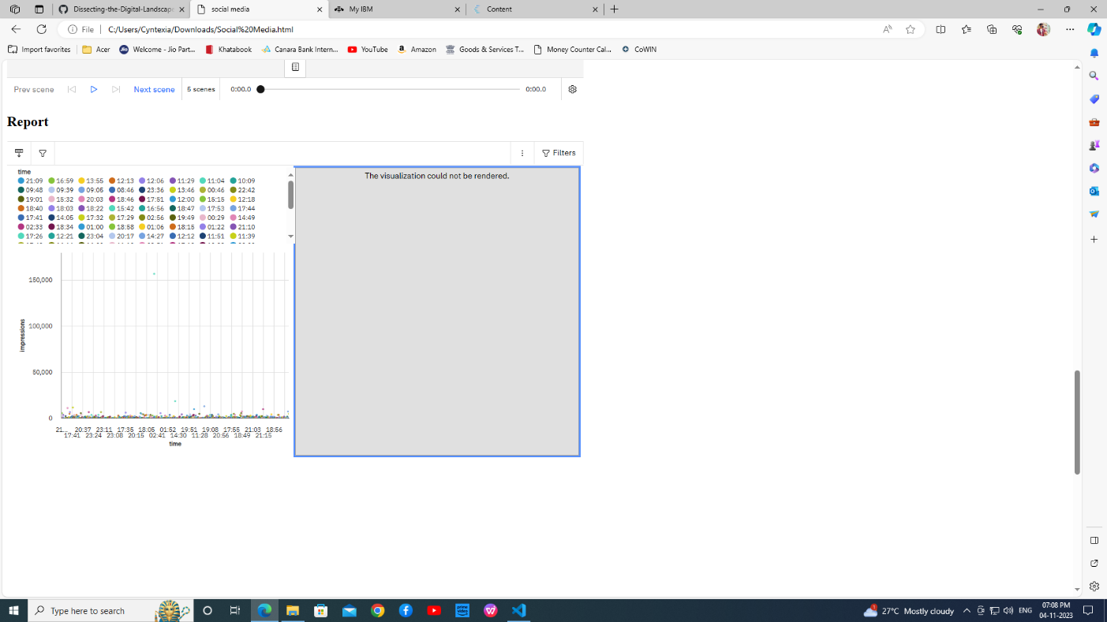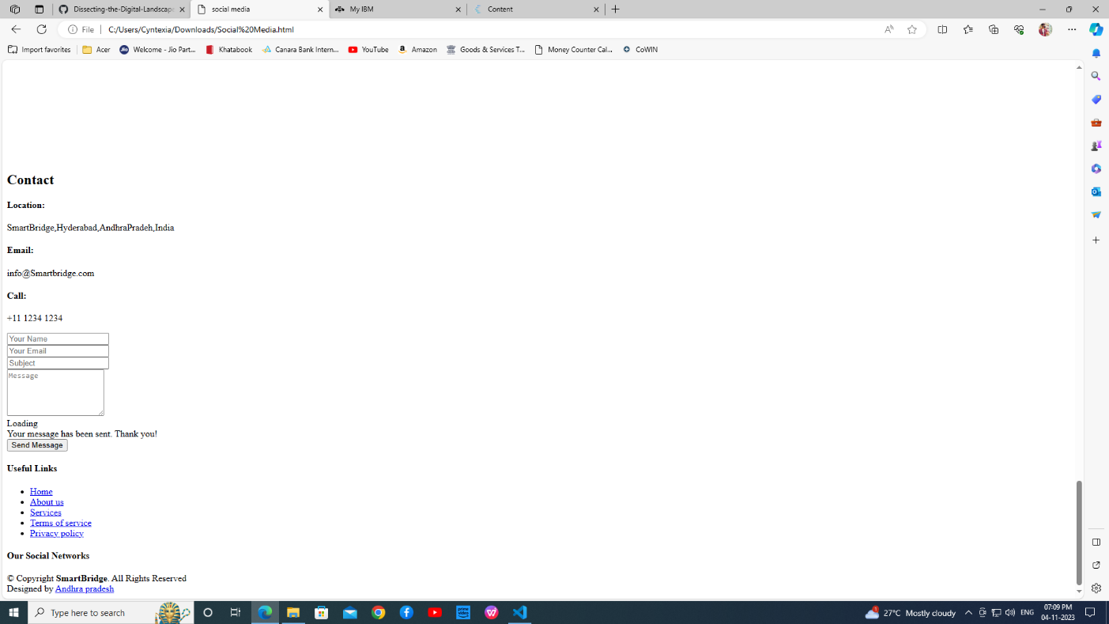

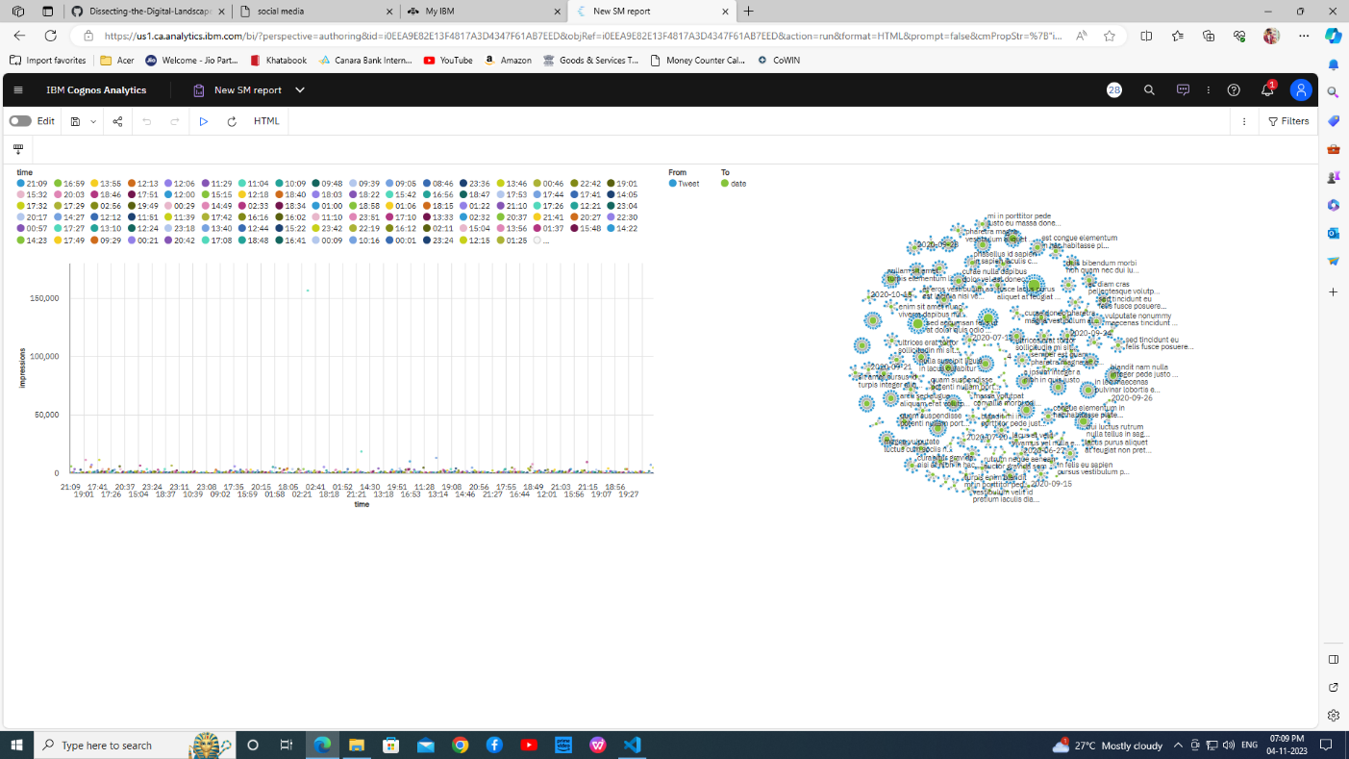

# ADVANTAGES & DISADVANTAGES

# ADVANTAGES:

# Performance Evaluation: Analysis allows you to assess the success of your social media efforts in achieving your objectives and KPIs. You can measure the effectiveness of your strategies and make adjustments as needed.

# Data-Driven Decision-Making: It provides valuable data and insights that can guide your decision-making. Instead of relying on intuition or guesswork, you can base your actions on empirical evidence.

# Audience Insights: Analysis helps you better understand your target audience, including their demographics, preferences, behaviors, and interests. This information enables you to create more relevant and engaging content.

# Competitor Benchmarking: You can gain insights into what your competitors are doing on social media, helping you identify opportunities and stay competitive in your industry.

# Optimized Content Strategy: Through analysis, you can identify which types of content resonate most with your audience, the best times to post, and which platforms are most effective for your goals. This leads to an improved content strategy.

# Cost-Effective Marketing: By understanding which campaigns and content perform well, you can allocate your budget more effectively, reducing wasteful spending on ineffective strategies.

# Improved Engagement: Analysis helps you identify which posts and interactions generate the most engagement. You can then replicate and build upon successful engagement strategies.

# Conversion Tracking: You can track the impact of your social media efforts on conversions, such as website visits, lead generation, or sales. This enables you to calculate the return on investment (ROI) for your social media marketing.

# Ad Performance Optimization: For paid social media advertising, analysis helps you refine ad campaigns, identify high-performing ad creatives, and adjust targeting to improve results.

# Crisis Management: Social media analysis allows you to detect potential crises early and respond proactively to manage and mitigate negative situations before they escalate.

# Feedback Collection: You can gather feedback directly from your audience through surveys, comments, and direct messages, helping you address concerns and improve user experience.

# Continuous Improvement: Regular analysis facilitates ongoing optimization. By identifying what works and what doesn't, you can iterate and improve your social media strategy over time.

# Trend Identification: Analysis helps you stay attuned to emerging trends and shifts in your industry, enabling you to adapt your strategy accordingly.

# Enhanced Customer Service: By monitoring and responding to customer inquiries and concerns on social media, you can improve customer service and build brand loyalty.

# Global Reach: Social media analysis can help you understand the global reach and impact of your social media efforts, enabling you to tailor content for different regions or markets.

# Measurable Impact: You can quantify the impact of your social media project, making it easier to communicate its value to stakeholders and senior management.

# Improved SEO: Social media activity can positively influence search engine optimization (SEO), and analysis can help you identify opportunities to enhance your SEO efforts.

# Community Building: Analysis can help you identify your most engaged and loyal followers, allowing you to foster stronger relationships with brand advocates and influencers.

# Resource Allocation: It helps you allocate resources effectively, ensuring that your time, budget, and personnel are used efficiently in support of your social media efforts.

# DISADVANTAGES:

# Data Privacy Concerns: Social media analysis often involves collecting and analyzing user data. This can raise privacy concerns, especially in the context of data protection regulations like GDPR and CCPA. Mishandling or misuse of user data can lead to legal and ethical issues.

# Data Quality and Accuracy: Social media data can be noisy and unstructured. Users may provide inaccurate information, use pseudonyms, or engage in deceptive practices. Analyzing unreliable data can lead to incorrect conclusions.

# Sample Bias: Social media analysis may not always represent the entire population, as not everyone uses or engages with social media. This can introduce sample bias and limit the generalizability of findings.

# Limited Context: Social media posts are often brief and lack context. Analyzing content out of context can lead to misunderstandings and misinterpretations.

# Negative Feedback and Trolls: Social media platforms can be rife with negativity, trolling, and abusive comments. Dealing with such content can be emotionally draining and potentially harmful to the mental health of those managing social media accounts.

# Algorithm Changes: Social media platforms frequently update their algorithms, affecting the visibility of content. What works today may not work tomorrow, making long-term planning challenging.

# Competitive Noise: The high level of competition on social media can make it difficult for a project to stand out. This can lead to saturation and reduced reach.

# Time-Consuming: Social media analysis can be time-consuming, as it requires consistent monitoring, data collection, and analysis. This can be a resource-intensive task.

# Data Overload: The volume of social media data can be overwhelming. Managing and analyzing this vast amount of information can be a daunting task.

# Misinformation and Fake News: Social media is a breeding ground for misinformation and fake news. Analyzing such content can perpetuate the spread of false information if not handled carefully.

# Measurement Challenges: Defining and measuring success on social media can be complex. Metrics like engagement and sentiment are often subjective and open to interpretation.

# Adverse Publicity: A poorly executed social media project can attract negative attention and backlash, harming a brand's reputation.

# Influence of Bots: Automated bots and fake accounts can artificially inflate engagement metrics and skew the analysis results.

# Content Saturation: Over time, the sheer volume of content on social media can lead to content saturation, making it harder for your messages to reach your audience effectively.

# Short Attention Spans: Social media users have short attention spans. Crafting content that captures and retains their interest can be challenging.

# Platform Dependency: Relying heavily on a single social media platform can be risky, as changes to that platform's policies or algorithms can significantly impact your project.

# Dependence on Trends: Some social media projects may need to align with current trends or viral topics, which can be unpredictable and short-lived.

1. **CONCLUSION**

In conclusion, analyzing a social media project is a comprehensive and iterative process essential for achieving success in the digital landscape. By delving into the various facets of your project, from objectives and KPIs to audience analysis and content strategy, you gain the tools needed for informed decision-making.

The data-driven insights derived from this analysis allow you to refine your strategies, adapt to ever-evolving trends, and ensure that your online presence remains relevant and engaging. Moreover, competitive insights provide valuable benchmarks for staying ahead of the competition, while tracking conversions and ROI is vital for projects with specific business goals. Equally important is the ability to mitigate risks through crisis management and maintain ethical standards in compliance with data privacy regulations.

Additionally, by considering sustainability and accessibility, you can enhance your project's social responsibility and reach a broader audience. In a dynamic digital environment, the analysis of your social media project serves as the compass guiding **your path to achieving your objectives, fostering** meaningful connections with your audience, and maintaining a positive online reputation.

Continual adaptation and evolution are key elements of social media project analysis. In a landscape where change is the only constant, your project should remain flexible and open to innovation. Regularly assessing the effectiveness of your content and engagement strategies helps you stay creative, ensuring that your content resonates with your audience.

Whether you're promoting a brand, product, or cause, the ability to swiftly pivot based on the insights from your analysis can be a game-changer. This adaptability not only keeps your project relevant but also empowers you to anticipate shifts in consumer behavior and market trends, enabling you to be proactive rather than reactive.

Furthermore, social media project analysis provides a vital platform for mitigating risks. Crises can arise at any moment in the digital realm, and an effective analysis allows you to identify potential issues early and implement crisis management strategies promptly. This is instrumental in safeguarding your brand's reputation and maintaining the trust of your audience.

# FUTURE SCOPE

# The future scope for the analysis of social media projects is vast and evolving rapidly, driven by technological advancements, changing user behaviors, and emerging trends. Here are some key areas where we can expect significant growth and innovation in the analysis of social media projects in the coming years:

# Advanced Data Analytics: As data collection methods and tools continue to improve, the analysis of social media data will become more sophisticated. Expect to see more in-depth data analytics, including predictive and prescriptive analytics to anticipate trends and suggest actions.

# Artificial Intelligence (AI) and Machine Learning: AI and machine learning will play a more prominent role in social media analysis. These technologies will be used for sentiment analysis, content recommendation, chatbots, and more.

# Deep Learning and Natural Language Processing (NLP): Deep learning techniques will enhance NLP capabilities, enabling better understanding of nuanced language, slang, and sentiment in social media conversations.

# Real-time Analysis: Real-time analysis of social media data will become even more critical. Brands and organizations will want to monitor and respond to trends and events as they happen to maintain relevance and manage crises.

# User Experience (UX) Analysis: Analyzing the user experience on social media platforms will become increasingly important. This includes understanding user interface design, accessibility, and user satisfaction metrics.

# Visual Analysis: With the growing importance of visual content on social media, tools for analyzing images and videos will become more prevalent. This will be essential for monitoring brand mentions in visual content and tracking trends in multimedia.

# Personalization and Customization: Social media analysis will focus on delivering highly personalized content to users, based on their preferences and behaviors, to enhance engagement.

# Privacy and Ethical Analysis: With increased concerns about data privacy, there will be a growing need to analyze the ethical implications of social media practices and ensure compliance with evolving data protection regulations.

# Blockchain for Data Security: Blockchain technology may be used to enhance the security and integrity of social media data, ensuring the authenticity of content and reducing the risk of data manipulation.

# Cross-Platform Integration: Comprehensive analysis tools that can aggregate and analyze data from multiple social media platforms in a unified manner will become more common.

# Augmented Reality (AR) and Virtual Reality (VR): The integration of AR and VR in social media will create new data analysis opportunities, especially for brands in industries like fashion, gaming, and entertainment.

# Emotion Analysis: A deeper understanding of user emotions expressed on social media will help in crafting more empathetic and responsive social media strategies.

# Trend Forecasting: Improved predictive analytics will enable organizations to forecast emerging trends and adapt their strategies accordingly.

# Sustainability Metrics: With the growing emphasis on sustainability and corporate social responsibility, social media analysis will incorporate metrics related to a brand's sustainability efforts and environmental impact.

# Integration with E-commerce: Enhanced integration between social media platforms and e-commerce, with advanced analytics, will enable businesses to directly measure ROI on social media sales efforts.

# Political and Societal Analysis: Analyzing the impact of social media on political and societal events will gain importance, with the potential for early detection of social and political trends and issues.

# Global Expansion: As social media continues to expand globally, the analysis of cross-cultural and multilingual social media data will become essential for international businesses.

# Compliance and Regulation Analysis: Analysis of compliance with various regulations, such as data protection laws and content moderation requirements, will be crucial for businesses operating on social media.

1. **APPENDIX**

**Source Code:**

<!DOCTYPE html>

<!-- saved from url=(0069)file:///C:/Users/ur/Downloads/Butterfly/Butterfly/SM.html%20code.html -->

<html lang="en"><head><meta http-equiv="Content-Type" content="text/html; charset=UTF-8">

<meta content="width=device-width, initial-scale=1.0" name="viewport">

<title>social media</title>

<meta content="" name="description">

<meta content="" name="keywords">

<!-- Favicons -->

<link href="file:///C:/Users/ur/Downloads/Butterfly/Butterfly/assets/img/favicon.png" rel="icon">

<link href="file:///C:/Users/ur/Downloads/Butterfly/Butterfly/assets/img/apple-touch-icon.png" rel="apple-touch-icon">

<!-- Google Fonts -->

<link href="./socialmedia page_files/css" rel="stylesheet">

<!-- Vendor CSS Files -->

<link href="./socialmedia page_files/bootstrap.min.css" rel="stylesheet">

<link href="./socialmedia page_files/bootstrap-icons.css" rel="stylesheet">

<link href="./socialmedia page_files/boxicons.min.css" rel="stylesheet">

<link href="./socialmedia page_files/glightbox.min.css" rel="stylesheet">

<link href="./socialmedia page_files/swiper-bundle.min.css" rel="stylesheet">

<!-- Template Main CSS File -->

<link href="./socialmedia page_files/style.css" rel="stylesheet">

<!-- =======================================================

* Template Name: Butterfly

* Updated: Jul 27 2023 with Bootstrap v5.3.1

* Template URL: https://bootstrapmade.com/butterfly-free-bootstrap-theme/

* Author: BootstrapMade.com

* License: https://bootstrapmade.com/license/

======================================================== -->

</head>

<body>

<!-- ======= Header ======= -->

<header id="header" class="fixed-top">

<div class="container d-flex align-items-center justify-content-between">

<a href="./socialmedia page_files/index.html" class="logo"><img src="./socialmedia page_files/index.html" alt="" class="img-fluid">A digital landscape</a>

<!-- Uncomment below if you prefer to use text as a logo -->

<!-- <h1 class="logo"><a href="index.html">Butterfly</a></h1> -->

<nav id="navbar" class="navbar">

<ul>

<li><a class="nav-link scrollto active" href="file:///C:/Users/ur/Downloads/Butterfly/Butterfly/SM.html%20code.html#hero">Home</a></li>

<li><a class="nav-link scrollto" href="file:///C:/Users/ur/Downloads/Butterfly/Butterfly/SM.html%20code.html#about">About</a></li>

<li><a class="nav-link scrollto" href="file:///C:/Users/ur/Downloads/Butterfly/Butterfly/SM.html%20code.html#Dashboard">Dashboard</a></li>

<li><a class="nav-link scrollto" href="file:///C:/Users/ur/Downloads/Butterfly/Butterfly/SM.html%20code.html#Story">Story</a></li>

<li><a class="nav-link scrollto" href="file:///C:/Users/ur/Downloads/Butterfly/Butterfly/SM.html%20code.html#Report">Report</a></li>

</ul></nav><!-- .navbar -->

</div>

</header><!-- End Header -->

<!-- ======= Hero Section ======= -->

<section id="hero" class="d-flex align-items-center">

<div class="container">

<div class="row">

<div class="col-lg-6 pt-4 pt-lg-0 order-2 order-lg-1 d-flex flex-column justify-content-center">

<h1>A Comprehensive Analysis of Social Media</h1>

<h2>A comprehensive and up-to-date understanding of the complex and dynamic world of social media</h2>

<div><a href="file:///C:/Users/ur/Downloads/Butterfly/Butterfly/SM.html%20code.html#about" class="btn-get-started scrollto">Get Started</a></div>

</div>

<div class="col-lg-6 order-1 order-lg-2 hero-img">

<img src="./socialmedia page_files/hero-img.png" class="img-fluid" alt="">

</div>

</div>

</div>

</section><!-- End Hero -->

<main id="main">

<!-- ======= About Section ======= -->

<section id="about" class="about">

<div class="container">

<div class="row">

<div class="col-xl-5 col-lg-6 d-flex justify-content-center video-box align-items-stretch position-relative">

<a href="https://www.youtube.com/watch?v=jDDaplaOz7Q" class="glightbox play-btn mb-4"></a>

</div>

<div class="col-xl-7 col-lg-6 icon-boxes d-flex flex-column align-items-stretch justify-content-center py-5 px-lg-5">

<h3>PROJECT OVERVIEW</h3>

<p>This paper presents the report of a social media analytics (SMA) review. The review conducted to find out the

methods and tools used in social media analytics, types of social media platforms which the SMA are performed

and the field which SMA has been performed. Social media contains a lot of user uploaded data in different

formats like text, images, photos, video etc. These large volumes of data are converted in meaningful information

which can be understood using different methods and tools which are called social media analytics

The paper has been reviewed according to the study

objectives. The study found that SMA tools and techniques which have been used are sentiment analysis, youtube

analytics, visible intelligence, IBM Watson tool and predictive models. The social media platforms which were

mostly used are twitter, facebook, youtube, trip advisor and blogs.

</p><div class="icon-box">

<div class="icon"><i class="bx bx-fingerprint"></i></div>

<h4 class="title"><a href="file:///C:/Users/ur/Downloads/Butterfly/Butterfly/SM.html%20code.html">Design process</a></h4>

<p class="description">The project followed this process: identifying the problem,literature review and understand,define the problem,ideate upon solutions and translate them into dashboards,reports,stories and visualizations

</p><div class="icon-box">

<div class="icon"><i class="bx bx-atom"></i></div>

<h4 class="title"><a href="file:///C:/Users/ur/Downloads/Butterfly/Butterfly/SM.html%20code.html">Types of platforms used for Socialmedia Analysis</a></h4>

<p class="description">The study found several social media platforms in the

reviewed articles, these platforms including twitter, Facebook,

Youtube, Tripadvisor and blogs. The most usable platform for

social media analytics was twitter. 77.27% of the reviewed

articles use twitter as the social media platform and the study

found that most of the analytics performed in twitter platform

was sentiment analysis</p>

</div>

</div>

</div>

</div>

</div></section><!-- End About Section -->

<!-- ======= Counts Section ======= -->

<!-- End Counts Section -->

<!-- ======= Clients Section ======= -->

<!-- End Clients Section -->

<!-- ======= Services Section ======= -->

<section id="Dashboard" class="services section-bg">

<div class="container">

<div class="section-title">

<h2>Dashboard</h2>

</div>

<iframe src="https://us1.ca.analytics.ibm.com/bi/?perspective=dashboard&amp;pathRef=.my_folders%2FSocial%2BMedia%2Bdashboard&amp;closeWindowOnLastView=true&amp;ui_appbar=false&amp;ui_navbar=false&amp;shareMode=embedded&amp;action=view&amp;mode=dashboard&amp;subView=model0000018b8bba330a_00000000" width="1000" height="1000" frameborder="0" gesture="media" allow="encrypted-media" allowfullscreen=""></iframe>

</div>

</section><!-- End Services Section -->

<!-- ======= Portfolio Section ======= -->

<section id="Story" class="portfolio">

<div class="container">

<div class="section-title">

<h2>Story</h2>

<iframe src="https://us1.ca.analytics.ibm.com/bi/?perspective=story&amp;pathRef=.my_folders%2FSocial%2BMedia%2Bstory&amp;closeWindowOnLastView=true&amp;ui_appbar=false&amp;ui_navbar=false&amp;shareMode=embedded&amp;action=view&amp;sceneId=-1&amp;sceneTime=0" width="1000" height="1000" frameborder="0" gesture="media" allow="encrypted-media" allowfullscreen=""></iframe>

</div>

</div></section><!-- End Portfolio Section -->

<!-- ======= Testimonials Section ======= -->

<!-- End Testimonials Section -->

<!-- ======= Team Section ======= -->

<section id="Report" class="team section-bg">

<div class="container">

<div class="section-title">

<h2>Report</h2>

<iframe src="https://us1.ca.analytics.ibm.com/bi/?pathRef=.my_folders%2FNew%2BSM%2Breport&amp;closeWindowOnLastView=true&amp;ui_appbar=false&amp;ui_navbar=false&amp;shareMode=embedded&amp;action=run&amp;format=HTML&amp;prompt=false" width="1000" height="1000" frameborder="0" gesture="media" allow="encrypted-media" allowfullscreen=""></iframe>

</div>

</div></section><!-- End Team Section -->

<!-- ======= Gallery Section ======= -->

<!-- End Gallery Section -->

<!-- ======= Contact Section ======= -->

<section id="contact" class="contact">

<div class="container">

<div class="section-title">

<h2>Contact</h2>

<p></p>

</div>

<div class="row mt-5">

<div class="col-lg-4">

<div class="info">

<div class="address">

<i class="bi bi-geo-alt"></i>

<h4>Location:</h4>

<p>SmartBridge,Hyderabad,AndhraPradeh,India</p>

</div>

<div class="email">

<i class="bi bi-envelope"></i>

<h4>Email:</h4>

<p>info@Smartbridge.com</p>

</div>

<div class="phone">

<i class="bi bi-phone"></i>

<h4>Call:</h4>

<p>+11 1234 1234</p>

</div>

</div>

</div>

<div class="col-lg-8 mt-5 mt-lg-0">

<form action="file:///C:/Users/ur/Downloads/Butterfly/Butterfly/forms/contact.php" method="post" role="form" class="php-email-form">

<div class="row">

<div class="col-md-6 form-group">

<input type="text" name="name" class="form-control" id="name" placeholder="Your Name" required="">

</div>

<div class="col-md-6 form-group mt-3 mt-md-0">

<input type="email" class="form-control" name="email" id="email" placeholder="Your Email" required="">

</div>

</div>

<div class="form-group mt-3">

<input type="text" class="form-control" name="subject" id="subject" placeholder="Subject" required="">

</div>

<div class="form-group mt-3">

<textarea class="form-control" name="message" rows="5" placeholder="Message" required=""></textarea>

</div>

<div class="my-3">

<div class="loading">Loading</div>

<div class="error-message"></div>

<div class="sent-message">Your message has been sent. Thank you!</div>

</div>

<div class="text-center"><button type="submit">Send Message</button></div>

</form>

</div>

</div>

</div>

</section><!-- End Contact Section -->

</main><!-- End #main -->

<!-- ======= Footer ======= -->

<div class="col-lg-3 col-md-6 footer-links">

<h4>Useful Links</h4>

<ul>

<li><i class="bx bx-chevron-right"></i> <a href="file:///C:/Users/ur/Downloads/Butterfly/Butterfly/SM.html%20code.html#">Home</a></li>

<li><i class="bx bx-chevron-right"></i> <a href="file:///C:/Users/ur/Downloads/Butterfly/Butterfly/SM.html%20code.html#">About us</a></li>

<li><i class="bx bx-chevron-right"></i> <a href="file:///C:/Users/ur/Downloads/Butterfly/Butterfly/SM.html%20code.html#">Services</a></li>

<li><i class="bx bx-chevron-right"></i> <a href="file:///C:/Users/ur/Downloads/Butterfly/Butterfly/SM.html%20code.html#">Terms of service</a></li>

<li><i class="bx bx-chevron-right"></i> <a href="file:///C:/Users/ur/Downloads/Butterfly/Butterfly/SM.html%20code.html#">Privacy policy</a></li>

</ul>

</div>

<div class="col-lg-3 col-md-6 footer-links">

<h4>Our Social Networks</h4>

<p></p>

<div class="social-links mt-3">

<a href="file:///C:/Users/ur/Downloads/Butterfly/Butterfly/SM.html%20code.html#" class="twitter"><i class="bx bxl-twitter"></i></a>

<a href="file:///C:/Users/ur/Downloads/Butterfly/Butterfly/SM.html%20code.html#" class="facebook"><i class="bx bxl-facebook"></i></a>

<a href="file:///C:/Users/ur/Downloads/Butterfly/Butterfly/SM.html%20code.html#" class="instagram"><i class="bx bxl-instagram"></i></a>

<a href="file:///C:/Users/ur/Downloads/Butterfly/Butterfly/SM.html%20code.html#" class="google-plus"><i class="bx bxl-skype"></i></a>

<a href="file:///C:/Users/ur/Downloads/Butterfly/Butterfly/SM.html%20code.html#" class="linkedin"><i class="bx bxl-linkedin"></i></a>

</div>

</div>

<div class="container py-4">

<div class="copyright">

© Copyright <strong><span>SmartBridge</span></strong>. All Rights Reserved

</div>

<div class="credits">

<!-- All the links in the footer should remain intact. -->

<!-- You can delete the links only if you purchased the pro version. -->

<!-- Licensing information: https://bootstrapmade.com/license/ -->

<!-- Purchase the pro version with working PHP/AJAX contact form: https://bootstrapmade.com/butterfly-free-bootstrap-theme/ -->

Designed by <a href="https://bootstrapmade.com/">Andhra pradesh</a>

</div>

</div>

<!-- End Footer -->

<a href="file:///C:/Users/ur/Downloads/Butterfly/Butterfly/SM.html%20code.html#" class="back-to-top d-flex align-items-center justify-content-center"><i class="bi bi-arrow-up-short"></i></a>

<!-- Vendor JS Files -->

<script src="./socialmedia page_files/purecounter_vanilla.js.download"></script>

<script src="./socialmedia page_files/bootstrap.bundle.min.js.download"></script>

<script src="./socialmedia page_files/glightbox.min.js.download"></script>

<script src="./socialmedia page_files/isotope.pkgd.min.js.download"></script>

<script src="./socialmedia page_files/swiper-bundle.min.js.download"></script>

<script src="./socialmedia page_files/validate.js.download"></script>

<!-- Template Main JS File -->

<script src="./socialmedia page_files/main.js.download"></script>

</body></html>

**GitHub & Project Demo Link**

**GitHub Link :** <https://github.com/Dineshkr9942/Dissecting-the-Digital-Landscape-A-Comprehensive-Analysis-of-Social-Media>

**Video Demo Link :**

<https://drive.google.com/file/d/1QmppAastPlXTpwsUURV0cFuSHb7A33Hb/view?usp=drive_link>